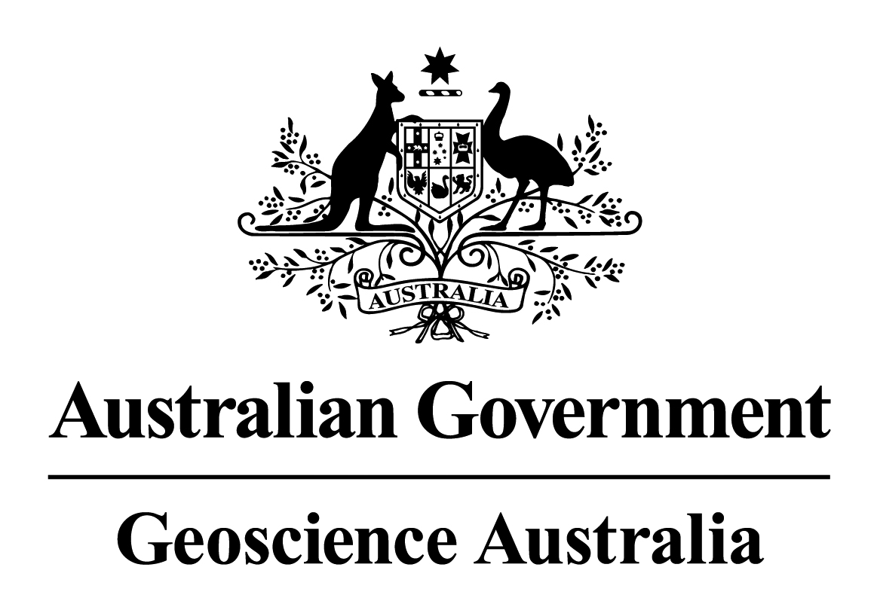

Creative Commons Attribution 3.0 Australia Licence

Important Notice
This Creative Commons Attribution 3.0 Australia Licence applies to the following Geoscience Australia products:
- 1s SRTM 2010 DEM, DEM-H, DEM-S
- 3s SRTM 2010 DSM, DEM, DEM-S
- 9s GEODATA 2008 DEM
You are free to:
- Share – to copy, adapt, distribute and transmit the work
- Remix – to adapt the work
By accepting this data you agree to the Terms and Conditions outlined below.

Terms and Conditions
Under the following conditions:
- Attribution – You must attribute the work as follows:

© Commonwealth of Australia (Geoscience Australia) 2012
Waiver — Any of the above conditions can be waived if you get permission from the copyright holder.
Public Domain — Where the work or any of its elements is in the public domain under applicable law, that status is in no way affected by the license.
Other Rights — In no way are any of the following rights affected by the license:
- Your fair dealing or fair use rights, or other applicable copyright exceptions and limitations;
- The author's moral rights;
- Rights other persons may have either in the work itself or in how the work is used, such as publicity or privacy rights.
Notice — For any reuse or distribution, you must make clear to others the license terms of this work. Follow this link for more information http://creativecommons.org/licenses/by/3.0/au/.

Applying geoscience to Australia’s most important challenges

